
RAMAIAH
INSTITUTE OF TECHNOLOGY
USN | 1 | M | S

(Autonomous Institute, Affiliated to VTU)
(Approved by AICTE, New Delhi & Govt. of Karnataka) Accredited by NBA & NAAC with ‘A’ Grade

MAKEUP EXAMINATIONS – FEBRUARY 2018

Course & Branch | : | B.E. : Computer Science & Engineering | Semester | : | V
Subject | : | Computer Networks | Max. Marks | : | 100
Subject Code | : | CS53/CS1553/CS514 | Duration | : | 3 Hrs

Instructions to the Candidates:
- Answer one full question from each unit.

 |  | UNIT- I
1. | a) | Compare persistent and non-persistent TCP connections that are used to configure HTTP clients and servers. | C01 | (06)
 | b) | Illustrate the basic operations of SMTP. | C01 | (08)
 | c) | Consider distributing a file of F = 15 Gbits to N peers. The server has an upload rate of us = 30 Mbps, and each peer has a download rate of di = 2 Mbps and an upload rate of u. For N = 100 and u = 700 Kbps, and 2 Mbps, Find the minimum distribution time for the Client Server distribution and for P2P distribution. | C01 | (06)
2. | a) | With a neat figure explain the interaction between various DNS servers. | C01 | (08)
 | b) | Differentiate between POP3 and IMAP. | C01 | (06)
 | c) | In the circular DHT shown below, suppose that peer 3 learns that peer 5 has left. How does peer 3 update its successor state information? Which peers are now its first and second successors? Suppose that a new peer 6 wants to join the DHT and it initially only knows peer 15’s IPaddress. What steps are taken?  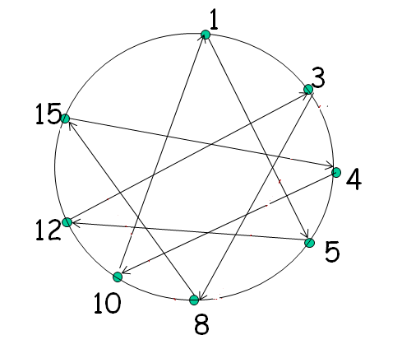 | C01 | (06)
 |  | UNIT- II
3. | a) | Suppose Host A sends two TCP Segments back to back to Host B over a TCP Connection. The First segment has sequence number 90 and the second has the sequence number 110.  i. How much data is in the first segment?  ii. Suppose that the first segment is lost but the second segment arrives at B. In the acknowledgement that Host B send to Host A, what will be the acknowledgement number? | CO2 | (04)
 | b) | Illustrate with neat figures the sequence of TCP states visited by the TCP client and TCP server. Explain the events that make the client and server to transition into these states. | CO2 | (10)
 | c) | What is meant by fairness in TCP? With an example explain how two TCP connections share single bottleneck link. What are the problems in sharing? | CO2 | (06)
4. | a) | Consider sending a large file from a host to another over a TCP connection that has no loss.  i. Suppose TCP uses AIMD for its congestion control without slow start. Assuming cwnd increases by 1 MSS every time a batch of ACKs is received and assuming approximately constant round-trip times, how long does it take for cwnd increase from 6 MSS to 12 MSS (assuming no loss events)?  ii. What is the average throughout (in terms of MSS and RTT) for this connection up through time = 6 RTT? | CO2 | (06)
 | b) | What is meant by fast recovery? Draw a neat graph that shows three phases of congestion control in TCP Variants. | CO2 | (08)
 | c) | What is meant by multiplexing and demultiplexing. Explain with neat diagram transport layer multiplexing and demultiplexing. | CO2 | (06)
 |  | UNIT- III
5. | a) | Describe all fields of IP packet format with a neat block diagram. | CO3 | (10)
 | b) | What is address depletion? Differentiate between sub netting and super netting. | CO3 | (06)
 | c) | Write an algorithm for Routing Information Protocol. | CO3 | (04)
6. | a) | Describe packet fragmentation and reassembly in detail with an example. | CO3 | (05)
 | b) | Write the Border Gateway packet format for the following:  - Open packet ii. Notification packet. | CO3 | (08)
 | c) | What is the difference between a group-shared tree and a source-based tree in the context of multicast routing? Explain with an example. | CO3 | (07)
 |  | UNIT- IV
7. | a) | With a neat figure illustrate the steps involved when a base station with common MSC decides to hand off its mobile user. | CO4 | (08)
 | b) | Discuss the 802.11 wireless architecture. | CO4 | (08)
 | c) | With a neat figure show the mapping between IP multicast and Ethernet multicast address. | CO4 | (04)
8. | a) | Describe how a mobile IP node registers its COA address with the home agent. | CO4 | (08)
 | b) | Define handoff. Differentiate between infrastructure mode and infrastructure-less network with an example. | CO4 | (08)
 | c) | What is the advantage of using sparse mode shared tree over dense mode source based tree. | CO4 | (04)
 |  | UNIT- V
9. | a) | Describe the components of H.323 protocol. | CO5 | (05)
 | b) | Write an algorithm for leaky bucket traffic shaping and explain with an example. | CO5 | (10)
 | c) | Write a note on per-hop behavior. | CO5 | (05)
10. | a) | What is the need of content distribution networks? Explain with an example CDN interactions with DNS. | CO5 | (09)
 | b) | Does the nonpreemptive priority queuing change the packet transmission orders, if bit-by-bit round –robin service is used? Discuss. | CO5 | (04)
 | c) | Consider a token –bucket traffic shaper. Let the bucket size be b bits and the token arrival rate be v b/s; let the maximum output data rate be z b/s. Derive an equation for T_{b} the time consumed for flow to be transmitted at the maximum rate. Find T_{b} when the bucket size is b=0.5Mb, v=10Mb/s, and z=100Mb/s. | CO5 | (07)

****************

